Happy Trip - Iteration 1
MindTree Document Template
Version 1.0 | 8 July 2013

Table Of Contents

1 Introduction 2
1.1 Definition 2
1.2 Objectives 2
1.3 Intended Audience 2
1.4 References 2
2 Release Summary 3
2.1 Testing carried for Iteration1 (MIDWise) 3
3 Test Summary 3
3.1 System Testing Summary 3
3.2 COMPREHENSIVE EVALUATION 4
3.3 Test Design 4
3.4 Defect Analysis 5
4 Testing Issues Requiring Resolution 6
5 Special Thanks 7
6 Recommendation 7
7 Appendices 7
8 Revision History 7

Introduction

Definition
The purpose of the Test Summary Report is to summarise the results of the designated testing activities done for Happy Trip-Iteration1 project and to provide evaluations based on these results. The Summary Report provides advice on the release readiness of the product, and documents any known anomalies or shortcomings in the product.

Objectives
The objective of this document is to provide the complete information on testing activities performed for Happy Trip-Iteration1 project.

Intended Audience
The intended audience of this report is Happy Trip team and Happy Trip Test team.

References
All the test artifacts present under <Mention the excel file name> designed using process templates for STLC.

Release Summary

Testing carried for Iteration1 (MIDWise)
<Sample Data>
MID | Total Test Cases | PASS | BLOCK | FAIL | Notes
MID 1 | 67 | 28 | 27 | 12
MID 2 | 78 | 26 | 31 | 21
MID 3 | 94 | 43 | 16 | 35
MID 4 | 80 | 5 | 61 | 14
Total | 862 | 343 (39.8%) | 265 (30.7%) | 254 (29.5%)

Test Summary

System Testing Summary
Testing Schedule
The following table provides the information on planned and actual testing schedule for Happy Trip –Iteration1 project.

PLANNED DATE | PLANNED ACTIVITY | ACTUAL DATE
28-May-2013  to  30-May-2013 | System Testing & UAT | Iteration1-28-May-2013 to 30-May-2013

Schedule variances in planned activities for a day, were due to – <examples as below can be sighted>
- Frequent unavailability of the application and database for each deployed URL group. And this hampered the planned activities but the scheduled items were completed on time. However, due to the non-testability of the major modules of the application critical bugs are yet to be fixed and once they are released for testing, it could have an impact on subsequent iteration’s planned activities
- Build was rejected by Java test team for iteration1 due to lot of S1 bugs, more than 60% Failed and Blocked test cases across teams/groups (Please refer section 2.1 for more test execution summary

COMPREHENSIVE EVALUATION
The Happy Trip – Iteration1 was tested for all the designed test cases. The metrics provided below gives complete information on the quality of the Application. Highlights of testing evaluation are as mentioned below.
- System testing has been carried out for all the planned Bug fixes in Iteration1.
- As part of Iteration1 systems testing, Team has identified that post regression & UAT the system is ready to be released.
- The HappyTrip system meets the acceptance criteria defined in test plan
What went well?
- Understood SRS document and came up with Requirement clarification log.
- Understood and implemented the mapping of defects to use cases /SRS sections
- Understood and identified test scenarios & test cases mapping to the corresponding defect requirements
- Exposed to the Test Plan template, Test Scenario template, Test case template, and Defect Tracking template
- Encouraged groups to do peer review and group review on test cases
- Understood & implemented categorization of test cases, based on types of testing identified for this iteration
- Introduced defect logging & defect lifecycle
- Implemented Defect logging
What would have gone well?
- System testing execution for iteration1 was planned to work on bug fixes on 8th July 2013, however due to payment gateway integration blocked, it had to be shifted to 9th July 2013. This led to loss of time.

Test Design
Test Execution on Status wise

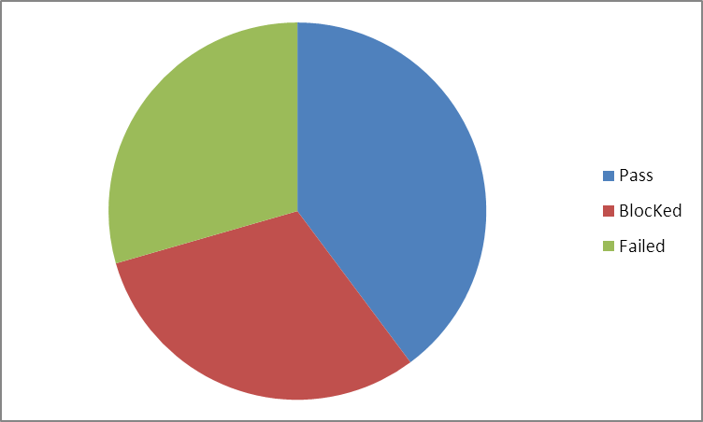

EmpID Wise Test case Execution

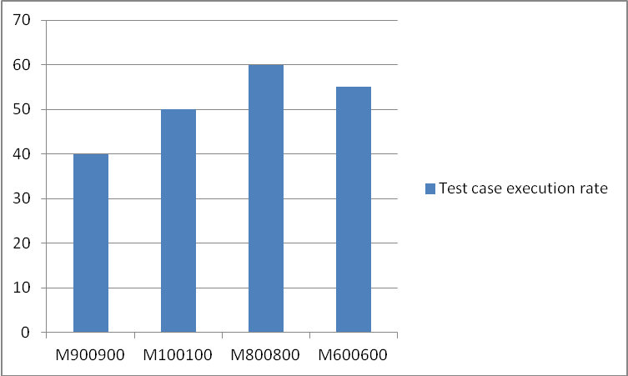

Defect Analysis
Defect Location metrics

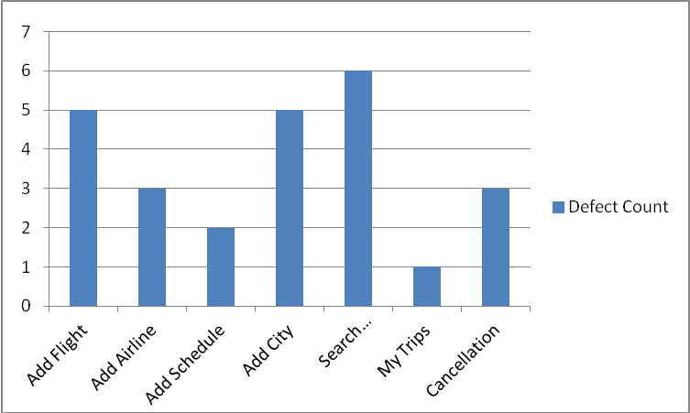

Defect Count MID wise
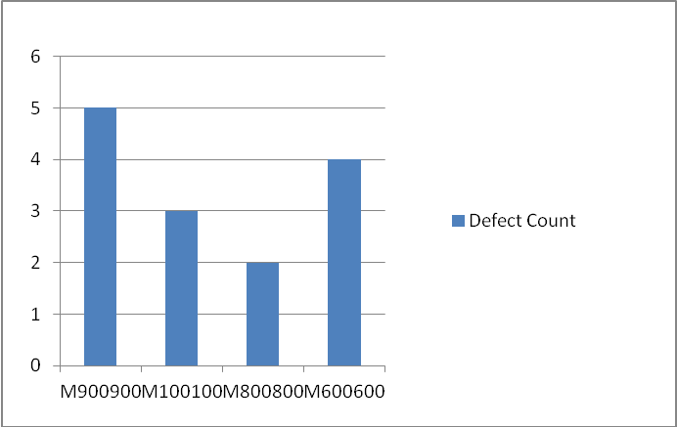

Testing Issues Requiring Resolution
The following issues are open which needs to be addressed before we take next build /Iteration.
Defect ID | Description | URL used
212 | Unable to search flights | http://172.22.200.127:8080/happytripclean1/home.html

Special Thanks
I thank to our test leads for providing us help in understanding Happy Trip project requirements and usage of artifacts produced as part of Iteration 1

Recommendation
We would like to recommend the following things for the application testing cycle.
- Provide appropriate messages for validations at field level

Appendices
NA

Revision History
Date | Version | Author | Comments
28-May-2013 | 1.0 | Priyanka Grover | Test summary report prepared based on the work performed for Iteration1 testing teams

